TCS DIGITAL SAMPLE QUESTIONS
ADVANCED APTITUDE
SET 1
Areas of Focus
Quantitative Aptitude | Logical Reasoning
Numbers | Logical Sequencing
Averages Mixtures and alligations | Picture Analysis
Time and Work | Word Puzzle
Permutation and Combination | Blood Relations
Geometry and Mensuration | Clocks
Ratio and Proportion | Cubes
Profit and loss | Data Arrangement
Time, Speed and Distance
Percentage
Probability
Ages
Progressions

- Each of Alia, Betty, Carol and Dalia took a test. Each of them answered at least one question correctly, and altogether they answered 67 questions correctly. Alia had more correct answers than anyone else. Betty and Carol together answered 43 questions correctly. How many correct answers did Dalia have?
- 1 B. 2 C. 3 D. 5

- An ant smartly moves across a staircase taking the shortest distance. Calculate the distance it takes to reach the top: B from A given that staircase consists of 2 steps. It is also known that the length, breadth and height is 6cm, 2cm and 1 cm respectively.
- 6 root 2 B. 6 C. 7 D. 2 root 19

- In this problem m! represents (m factorial), or the number that results when multiplying 1,2,3,….m. Hence 4! = 1*2*3*4 = 24.
For how many values of n, is [(n!)²+23] a perfect square?
- 4 B. 3 C. Infinitely many D. 0

- The rupee/coin changing machine at a bank has a flaw. It gives 10 ten rupee notes if you put a 100 rupee note and 10 one rupee coins if you insert a 10 rupee note but gives 10 hundred rupee notes when you put a one rupee coin. Sivaji, after being ruined by his rivals in business is left with a one rupee coin and discovers the flaw in the machine by accident. By using the machine repeatedly, which of the following amounts is a valid amount that Sivaji can have when he gets tired and stops at some stage (assume that the machine has an infinite supply of notes and coins):
- 26975 B. 53947 C. 18980 D. 33966

- A spherical solid ball of radius 58 mm is to be divided into eight equal parts by cutting it four times longitudinally along the same axis. Find the surface area of each of the final pieces thus obtained (in mm^2)? (where pi= 22/7)
- 3365pi B. 5046pi C. 1682pi D. 3346pi

- Professor absentminded has a very peculiar problem, in that he cannot remember numbers larger than 15. However, he tells his wife, I can remember any number up to 100 by remembering the three numbers obtained as remainders when the number is divided by 3, 5 and 7 respectively. For example (2,2,3) is 17. Professor remembers that he had (1,1,6) rupees in the purse, and he paid (2,0,6) rupees to the servant. How much money is left in the purse?
A. 59 B. 61 C. 49 D. 56

- An ant starts moving on the mesh shown below along the wires towards a food particle. If the ant is at the bottom-left corner of cell A and the food is at the top-right corner of cell F, then find the number of optimal routes for the ant.

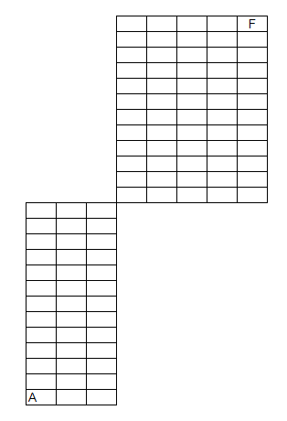
- 13884156 B. 3465280 C. 4368 D. 6748

- Two identical circles intersect so that their centers, and the points at which they intersect, form a square of side 1 cm. The area in sq. cm of the portion that is common to the two circles is:
A. (π/2) – 1 B. 4 C. √2 – 1 D. √5

- A call center agent has a list of 305 phone numbers of people in alphabetic order of names (but she does not have any of the names). She needs to quickly contact Deepak Sharma to convey a message to him. If each call takes 2 minutes to complete, and every call is answered, what is the minimum amount of time in which she can guarantee to deliver the message to Mr. Sharma?
A. 18 minutes B. 610 minutes C. 206 minutes D. 34 minutes

- Seven movie addicts- Guna, Isha, Leela, Madhu, Rinku, Viji and Yamini attend a film festival. Three films are shown, one directed by Rajkumar Hirani, one by S.Shankar, and one by Mani Ratnam. Each of the film buffs sees only one of the three films. The films are shown only once, one film at a time. The following restrictions must apply :- Exactly twice as many of the film buffs sees the S.shankar film as see the Rajkumar Hirani film.- Guna and Rinku do not see the same film as each other.- Isha and Madhu do not see same film as each other.- Viji and Yamini see the same film as each other.- Leela sees the S.Shankar film.- Guna sees either the Rajkumar Hirani film or the Mani Ratnam film.Which one of the following could be an accurate matching of the film buffs to films ?(A) Guna: the S.Shankar film; Isha: the Mani Ratnam film; Madhu: the S.Shankar film(B) Guna: the Mani Ratnam film; Isha: the Rajkumar Hirani film; Viji: the Rajkumar Hirani film(C) Isha : the S.Shankar film; Rinku: the Mani Ratnam film; Viji: the Rajkumar Hirani film(D) Madhu: the Mani Ratnam film; Rinku: the Mani Ratnam film; Viji: the Mani Ratnam film
- D B. C C. B D. A

- A sudoku grid contains digits in such a manner that every row, every column, and every 3x3 box accommodates the digits 1 to 9, without repetition. In the following Sudoku grid, find the values at the cells denoted by x and y and determine the value of 6x + 15y.

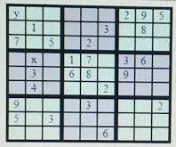

- 87 B. 75 C. 66 D. 99

- Eric throws two dice, and his score is the sum of the values shown. Sandra throws one die, and her score is the square of the value shown. What is the probability that Sandra’s score will be strictly higher than Eric’s score?
A. 137/216 B. 17/36 C. 173/216 D. 5/6

